Oct. 25, 2019

PeerForward Taps its Own Gary Z. Linnen, Youth Development Innovator, to be New CEO

Washington, DC – PeerForward is pleased to announce long-time leader in the organization,
Gary Z. Linnen, will become its new Chief Executive Officer. Mr. Linnen, currently serving as Managing Director for Program Operations and Innovation, will be responsible for leading PeerForward as it creates new ways to scale the highly effective PeerForward Method to more high schools serving low-income communities and expands its services to students in need on college campuses to fulfill PeerForward’s mission to connect students in low-income communities to higher education and careers.

“As CEO, Gary will bring to PeerForward personal commitment and accountability, executive presence and leadership, extensive knowledge and first-hand experience in college access and persistence, and broad stakeholder support to lead PeerForward to the next level,” said Nicholas M. Florio, Chairman of the PeerForward Board of Directors.

Mr. Linnen holds a bachelor’s degree from Cornell University and worked at The Princeton Review before joining PeerForward (then known as College Summit) in 2007. He is a gifted facilitator, having trained thousands of youth and educators in his career. He worked his way up at PeerForward from school partnership manager to program director to his most recent position as Managing Director, Program Operations and Innovation. The PeerForward Board unanimously agreed, after an extensive national search, that Mr. Linnen was the right person to lead the organization into the future.

“More than 12 years ago I joined PeerForward to be part of a team of trendsetters who fostered a movement to change the course of college persistence and career aspirations for our youth in America. These youth, past and present, are powerful people who deserve all of the great benefits life has to offer, regardless of their zip code,” said Mr. Linnen, who grew up in Spanish Harlem, NYC, and was the first in his family to earn a college degree. “Hence, I am beyond elated to stand on the shoulders of our co-founders, staff, alumni, community stakeholders, Peer Leaders and supporters to lead the work at PeerForward.”

Mr. Linnen not only is the first non-founder to serve as PeerForward’s CEO, but he is the first of Afro-Latino descent, reflecting the organization’s commitment to diversity, equity, and inclusion. Of the 85,000 students in partner schools PeerForward serves annually, 94 percent are minority students and 70% are low-income. Mr. Linnen will build on the momentum that current CEO and Co-founder, Dr. Keith Frome, has generated over the last five years as the organization adopted a powerful student-led model that has increased impact while cutting costs. Dr. Frome will continue to serve as the Executive Chair of the Board of Directors after Mr. Linnen formally takes the reins May 1, 2020.

“When I heard the news of Gary’s appointment, I was thrilled. It was an emotional moment because I have spent the better part of my adult life with the organization. I know that Gary will be a highly effective leader and executive,” Dr. Frome said. “Gary is beloved by our staff, volunteers, alumni, and Peer Leaders. Gary embodies who we are, whom we serve, and where we are going.”

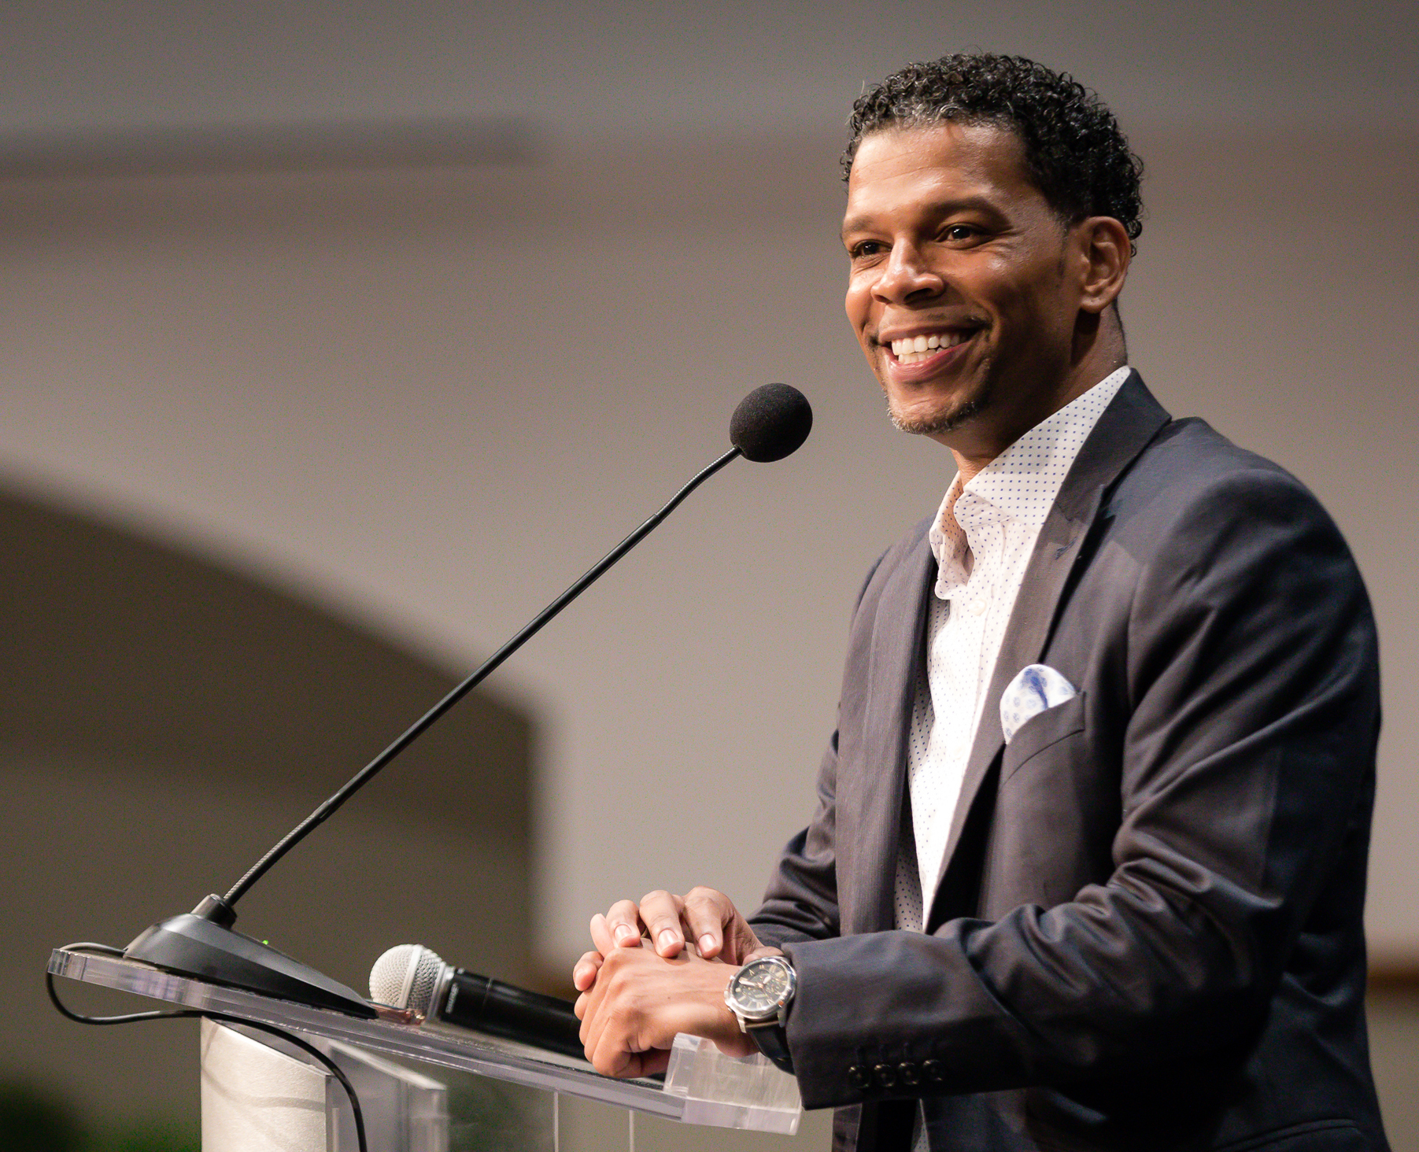
About Gary Z. Linnen
CEO-elect, PeerForward
Gary Z. Linnen brings a wealth of personal and professional experience to his new role of CEO of PeerForward. Mr. Linnen has lived similar experiences as many of the students the organization serves, growing up in the projects of Spanish Harlem and being the first in his family to earn a four-year college degree. After leading operations, tutoring, and supplemental services for The Princeton Review, Mr. Linnen joined the PeerForward staff in 2007 as a school partnership manager. In his 12 years at PeerForward, Mr. Linnen has led program, operations, and innovation, and honed keen insights into the nexus of content, logistics, community context, and educational impact. He is a gifted facilitator and trainer of students and educators, having conducted numerous national professional development seminars on college access, youth empowerment, and strategic partnerships. Mr. Linnen has been instrumental in raising money for PeerForward and in creating effective alumni engagement strategies that have led to 100% alumni staffing of PeerForward’s transformational summer workshops. He has led the development and continuous improvement of program offerings and tools, including the premier high school program adopted four years ago and a new offering for college campuses initiated in 2018. Mr. Linnen is the first non-founder and the first of Afro-Latino descent to serve as PeerForward’s CEO. Mr. Linnen holds a bachelor’s degree in government from Cornell University and is a member of Princeton University’s AlumniCorps Emerging Leaders 2020 cohort. He lives in New York City.

About PeerForward
PeerForward’s mission is to unleash the power of positive peer influence to transform the lives of youth living in low-income communities by connecting them to college and careers. PeerForward increases higher education enrollment rates in high schools serving low-income communities, and helps students persist once they get to college. PeerForward has been an innovator in guiding students to and through higher education for more than two decades by tapping a readily available resource found in every school and college campus– influential students.

Contact info: Reagan Walker, Managing Director for Marketing and Communications,
rwalker@peerforward.org, 202-319-1763, ex. 289

